[](https://www.google.com.au/url?sa=i&rct=j&q=&esrc=s&source=images&cd=&cad=rja&uact=8&ved=0ahUKEwjQ7fTemZPPAhVByWMKHeDEDgYQjRwIBw&url=https://www.linkedin.com/company/south-metropolitan-tafe&psig=AFQjCNEFIfsKzjI-Du_wWVtg2iFpGFsQow&ust=1474091722917468)

**CNC LATHE PROJECT**  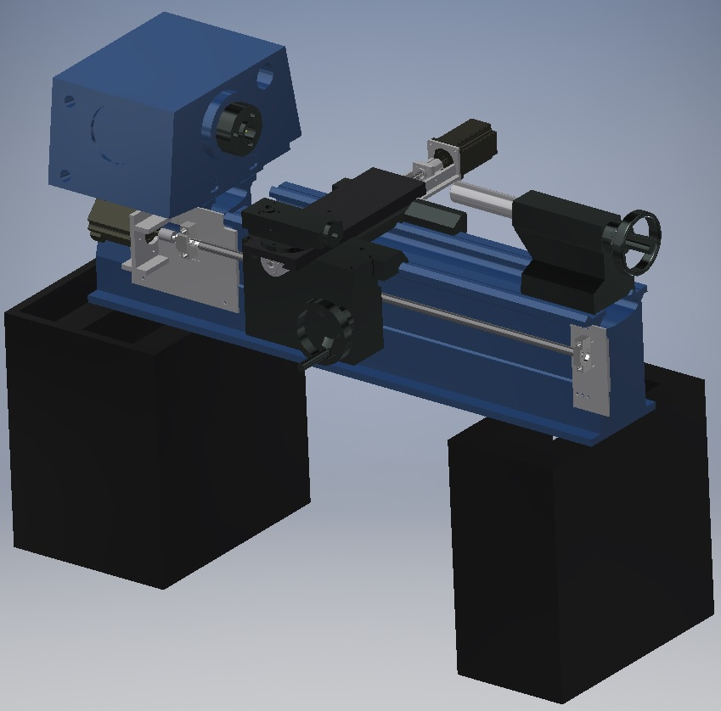

FINAL PERSONAL REPORT

INSTRUCTOR: **ROSS JAVIS**

TRAN HOAI UC – M215104

DATE: 05/12/2017

**Contents**

Introduction 3

Progression 3

Gear box 3

Ball screw selection 3

Base support 5

Conclusion 7

# Introduction

The specifications of the Colchester 1800 Lathe

The Motor was capable of reaching 2.2kW (3 h.p) which was directed by a twin V-Belt gear set up. Which was also 3 phase as well.

Swing Over: Bed 342mm, Cross Slide 215mm, Gap 480mm

Distance Between Centres: 609mm

Floor Plan / Foot Print: 1.7m x 1.15m

Weight: 0.79 Tons Approx.

Equipped with: 3 & 4 Jaw Chucks, Low Volt Light, and Imperial/Metric threading and coolant & chuck guard.

The purpose of this report shows the modification of a current mechanical lathe which will be modified into a Computer numeric control (CNC) lathe machine. With the specific work space of 2.1m wide and 5.5m long, additional servo motor and ball screw will be driving the X.

Specifically, the modifying X-axis will drives the cross-slide which will carries the tool post, with the travel distance of 170mm back and forth along the axis.

By using the Inventor program, we will modelling all the parts and assembly them into a complete form of a lathe. Afterwards, remodel the design and research a method to insert necessary factors on the X-axis.

Those factors are taken into considerations to be able to drive the tool post along the shaft as sections below:

* **Gear box**
* **Ball screw selections**
* **Base support and relevant models**
* **Positioning the motor and additional modification of tool post**.

# Progression

## Gear box

Using the current measuring tools to replicate the Gear box model in Inventor. However, due to an amount of complicated details on the outside and inside the gear box, the appearance of the model is limited with the main components such as the general shape, shaft’s holes and some apparent details according to Ross.

## Ball screw selection

Due to the research calculation from the current model, the Ball Screws that had been decided from **THK** website, will be changed into NSK due to the unavailability from the THK. As the results, the process of re-selection of the ball screws on NSK brand leads to the rolled ball screws of R series (RNTL 1405A2.5S)

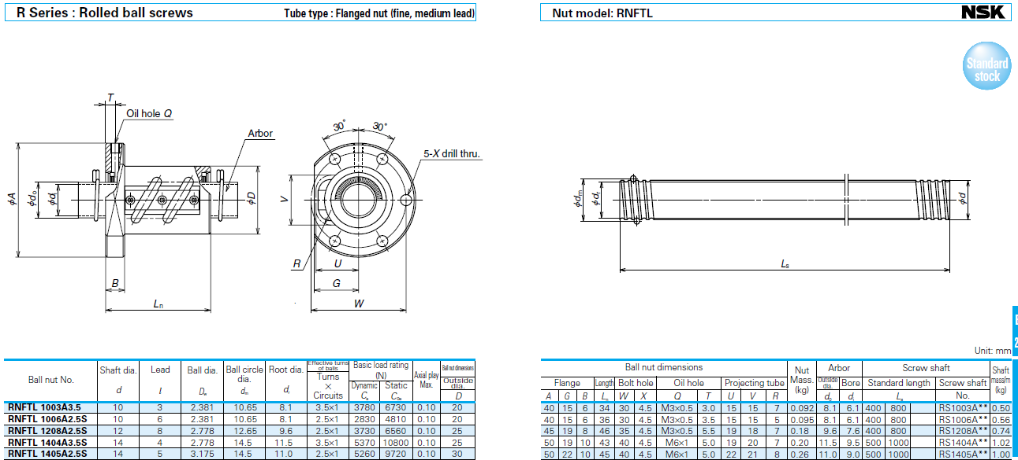

**Ball screws technical data for selection**

The previous ball screw had a shaft diameter of **16mm**. However, the one from the NSK does not have the same diameter in the data sheet. **NSK** has only **14mm** diameter so that closer to the original selection according to the calculation.

For the shaft, the length has been decided at 530mm. However, the default order is 600mm or 1200mm so that we will modify the shaft when it arrives.

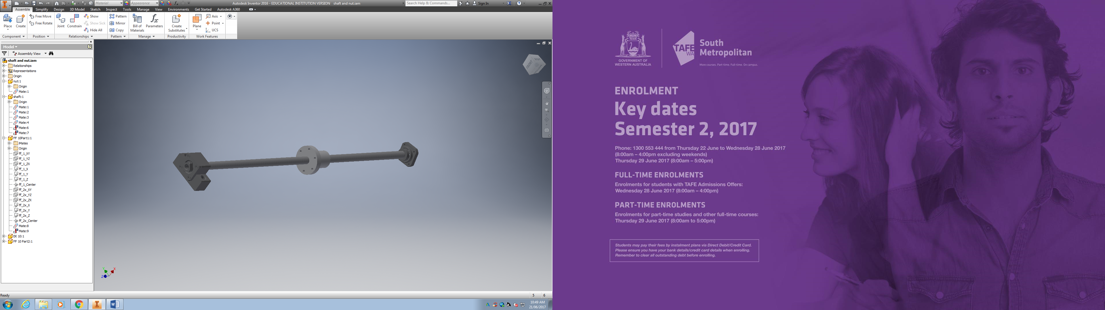

In addition, the shaft has the rectangular fixed support and round support at the other end.

**The cross-slide limitation** will be -40mm and 60mm in the X-Axis.

Disassembly the apron to modify later on.

Base on the saddle, create the support to hold the motor that will control the ball screws along the X-Axis.

Modifying the ball screw by cutting the edge to fit in between the **Saddle** and the **cross-slide** (50mm width, 33mm height), also creating the **Nut Bracket** to mount the ball screw into the **cross-slide**

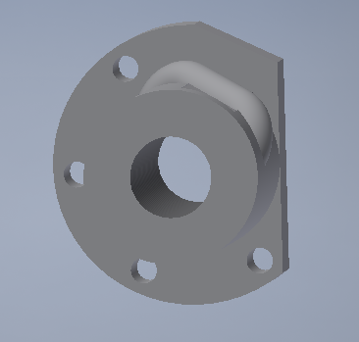

**Modified ball screw**

## 

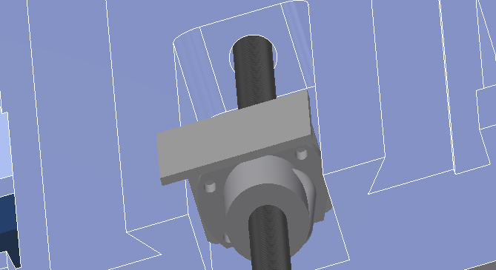

**Mounted ball screw with the Nut Bracket**

## Base support

The base support is required to be able to hold a 4 kg motor which has a running torque of 8Nm. In addition, a spacer which holds the end of the shaft, had been made by TOM and machined to allow the cross-slide passing through.

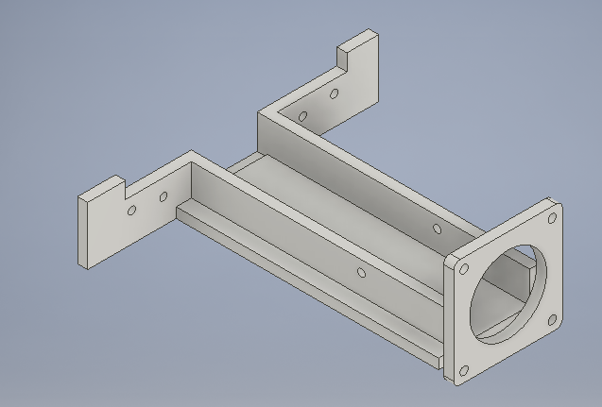

**CAD drawing is handed to TOM to produce**

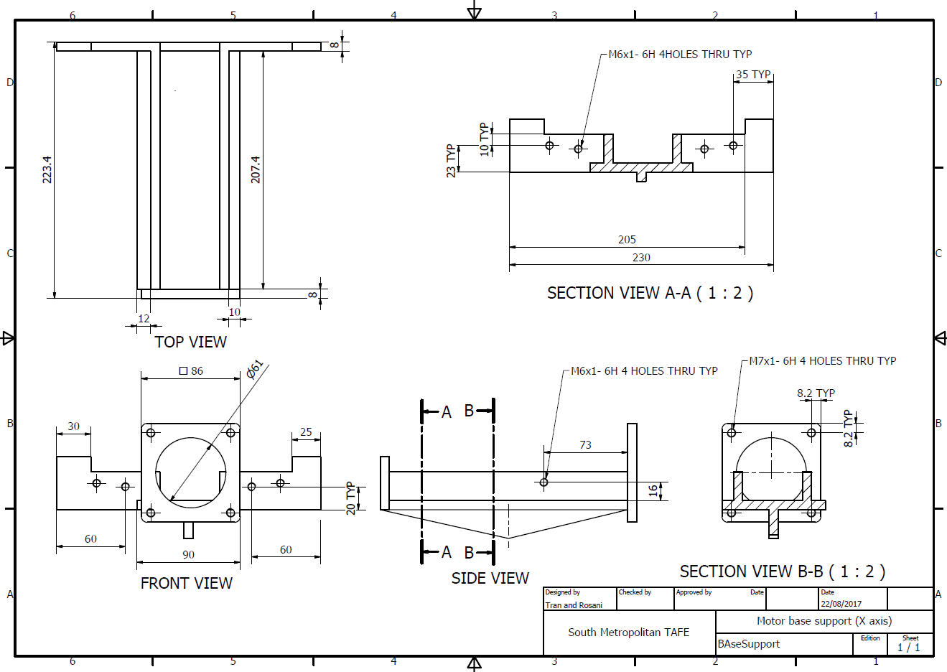

**Flexible coupling**

A part that is necessary to run the shaft by the motor, is required. As the shaft has an end of 8mm diameter and the motor has the shaft of 14mm of diameter. Also, to be able to hold the torque of the motor. Thus, the flexible coupling which is decided between Ross and Rosani and I was a flexible coupling with **clamp style shaft connection** which has an outer diameter less than **30mm**.

# Conclusion

The time had taken to design the part is longer than it should be due to a few unexpected occurrences.

Firstly, the incorrect measurements from the other parts that affected the precision of the X-axis. This could leads to incorrect position of the shaft on the axis, so that the other designs could become a result of a failure CNC machine.

Secondly, the stakeholder who is Ross Javis, had been changing his desires. Such as:

- On the first term of semester: the motor on the side of apron at first.

- 31/10/2017: An idea of relocate the motor to the other side of the Lathe due to the collision between the cross-slide and the base support. In addition, we received wrong motors (smaller) due to supplier’s mistake.

- 07/11/2017: Relocate the Tool-Post 50mm further from the initial position so that the cross-slide will not touch the motor’s base support.

Finally, unexpected events such as long waited products purchase, or incorrect measurement from the parts could affect the entire schedule of the project.

# RECOMMENDATION

The most critical point that we had learnt on the hard way was the precision of measurement of the parts. If the measurements are incorrect, they could ruin the entire assembly such as constrains between all the parts that leads to out of vision design, the modellings are not as close as the actual part.

Task delegations for team member should be distributed accordingly. However, whoever goes behind or cannot be finished due to schedule should have given a warning and reported to Stakeholder.

# References

<http://oceancontrols.com.au/home.php>

# <https://www.thkstore.com/>

# Appendix

## 

|  |  |  |  |  |  |  |  |  |
| --- | --- | --- | --- | --- | --- | --- | --- | --- |
| **Identify Hazards and subsequent Risks** | **Analyse Risks & Evaluate Risks** | | | **Identify and evaluate existing risk controls** | | | **Further Risk Treatments** | **Standards** |
|
| **Hazards/Issues/Risks** | **Consequence** | **Likelihood** | **Risk level** | **What we are doing now to manage this risk**. | **Effectiveness of our strategies** | **New risk level** | **Further action needed** |
| **Opportunities for improvement** |
| **MECHANICAL** | | | | | | | |  |
| Flying objects such as the chuck key left in chuck | 4 | E | H | Barrier between the workpiece and operator (Protective cover) | Reduces the risk of flying object | L | Voice control | AS 4024.1601-2006 4.6.1(a) , 6.1.3 AS4024.1-1996 (15.3.2.4) |
| Cutting tool injury when cleaning,  filing or polishing (machine off) | 1 | D | L | Risk sign. Authorization | Let people be aware of possible  risk | L | Training | AS 4024.1601-2006 6.3.5, .4.2. 10.2 |
| Metal chips and swarf coming loose | 3 | A | X | Barrier between the workpiece and operator (Protective cover) and the usage of PPE | Reduces the possibility of chips flying out of the machine | L | Voice control | AS 4024.1601-2006 4.6.1(a) |
| Rotating machine parts- entanglement | 5 | E | H | Machine stops when door is open (Mechanical sensor) | Prevent people from getting caught | L | Preventive action | AS 4024.1601-2006 4.6.1(a) AS 4024.1-1996 (15.3.2.3) |
| Closing movements of parts under  power can result finger trapping | 4 | C | X | Machine stops when door is open (Mechanical sensor) | Prevent people from getting caught | L |  | AS 4024.1601-2006 4.6.1(a) AS 4024.1801-2006 |
| Work pieces can very hot | 2 | D | L | Monitoring coolant flow | Assure coolant is running at all time | L | PPE |  |
| Contact with cutting fluids, oil and grease can irritate skin | 1 | B | M | PPE | Prevent skin from contacting fluids | L | PPE | AS 4024.1601-2006 6.1.4 AS 4024.1-1996 (15.4) |
| Swarf can jam the machine or be  ejected if allowed | 1 | E | L | Power protection | Neither motor nor swarf jam have contact with the operator | L | - |  |
| Eye injury | 4 | D | H | Barrier between the workpiece and operator (Protective cover) | Reduces the risk of flying object | L | PPE | AS 4024.1601-2006 4.6.1(a) |
| **ELECTRICAL** | | | | | | | |  |
| Electrocution | 5 | E | H | Check all cables before turning on lathe | Reduce the likelihood of Electrocution | M | Install RCA | AS/NZS 3000:2007 |
| Electric shock | 4 | E | H | Check all cables before turning on lathe | Reduce the likelihood of Electric shock | M | Install RCA | AS/NZS 3000:2007 appendix L |
| Soldering Iron Burns | 2 | C | M | Check the heat from the lathe and training | Lower the risk of damage to person | L | Use Common sense |  |
| Proximity Switch Failure | 3 | D | M | Test switches with lathe off | Assure the function of the switches and replacement of broken switches | L | Recheck switches periodically | AS/NZS 3000:2007 (7.2.2.2) |
| Safety Switches Failure | 3 | D | M | Test switches with lathe off | Assure the function of the switches and replacement of broken switches | L | Recheck switches periodically | AS 4024.1.-1996 (15.3.2.8) |
| Catastrophic Lathe Failure | 4 | E | H | Add an safety stop button | Allows the operator to stop the lathe before catastrophic injury happens | M | PPE | AS 4024.1.-1996 (15.3.2.8) |